Step1：I chose to create a 'learning platform' website to meet the various needs mentioned in the final project, including math calculations, tables, dates, navigation, web security, and more.

Step2：First of all I created an index.html page and added the math Calculation page and functionality. Currently in my final project folder I have created two folders 'js', 'css' and the current code screenshot is below:

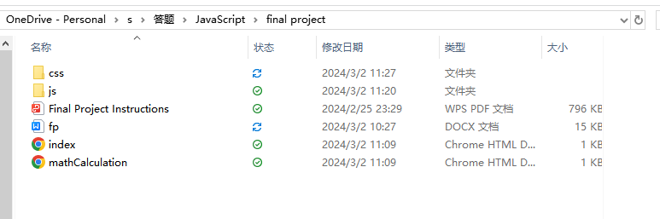

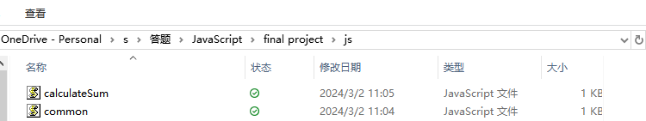

Index.html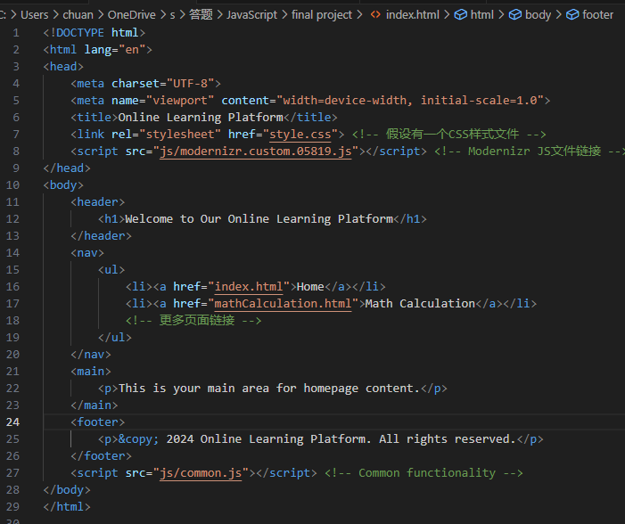

mathCalculation.html

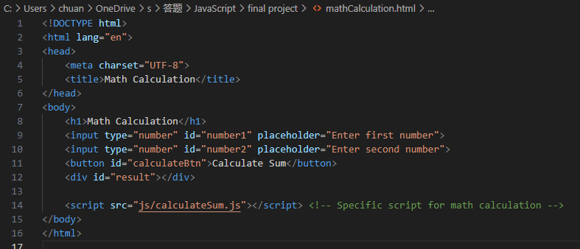

Common.js

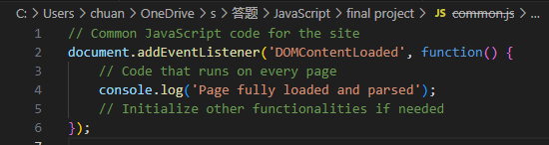

calculateSum.js

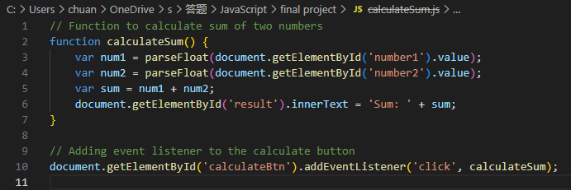

Step3：Continuing to add new functionality to the page as required by the final project: the feedback and membership duration pages. The code added is 'feedback.html', 'feedbackValidation,js', 'membershipDuration. html', 'membershipDuration.js'. Two of the files with js suffixes should be placed in the js folder.

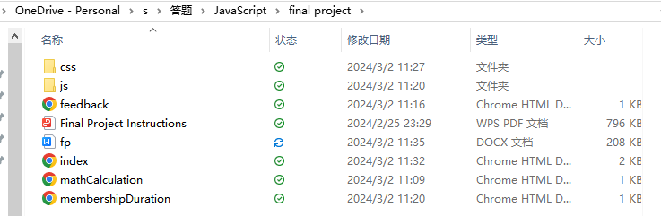

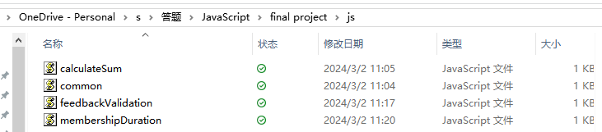

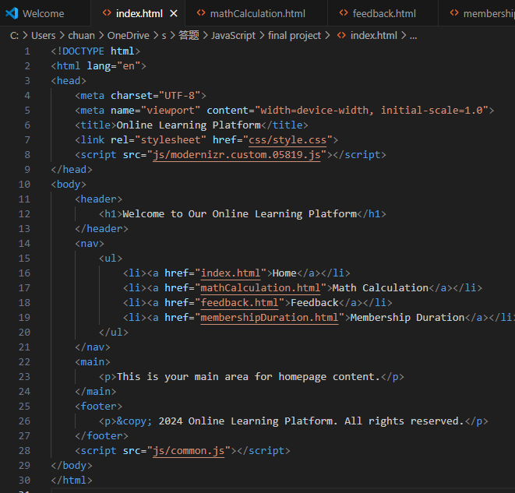

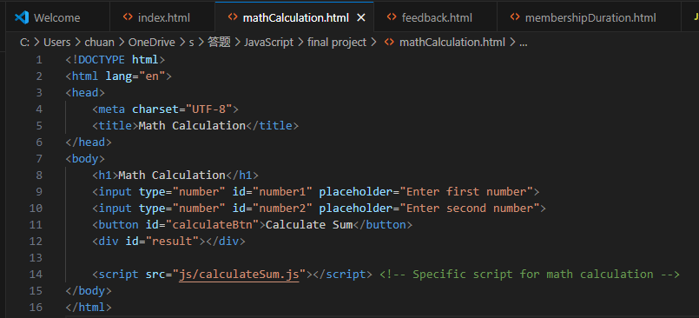

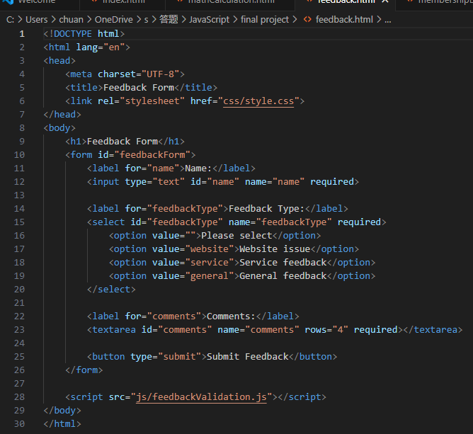

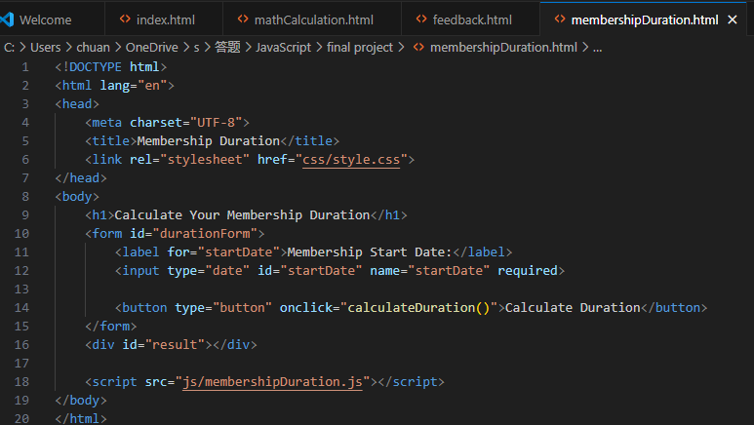

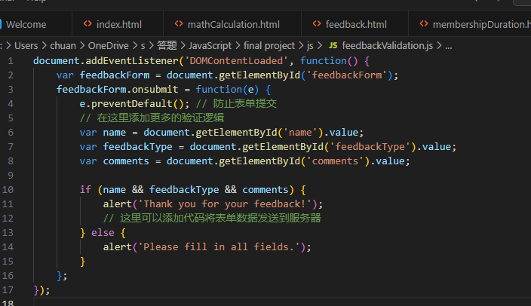

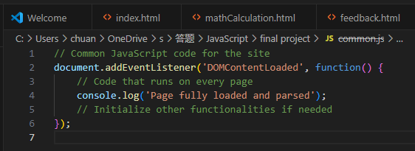

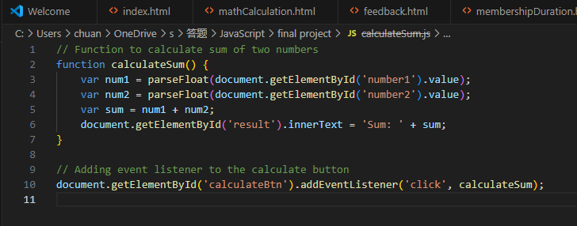

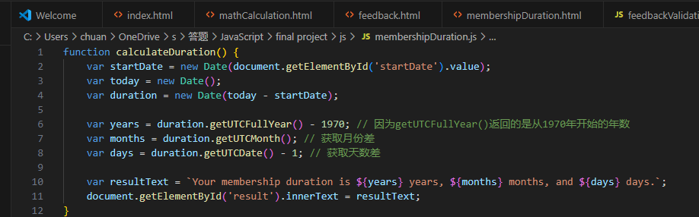

Step4：Next I add ajax functionality that uses ajax to fetch data and exchange it with the server to update the page content without reloading the entire page.

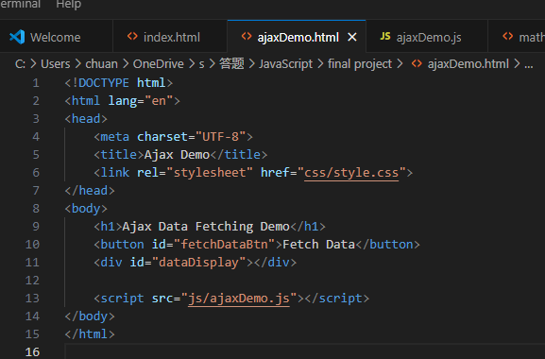

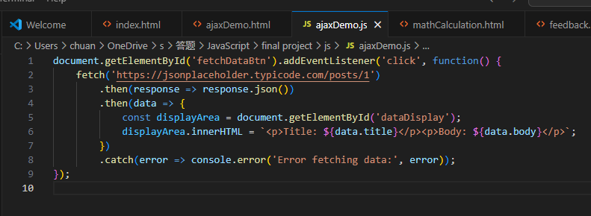

Step5： Continue to add functionality as required by the final project. Add a feedback type selection with multiple options in feedback.html. The user can select one or more feedback types and the selection will be dynamically added to an array.

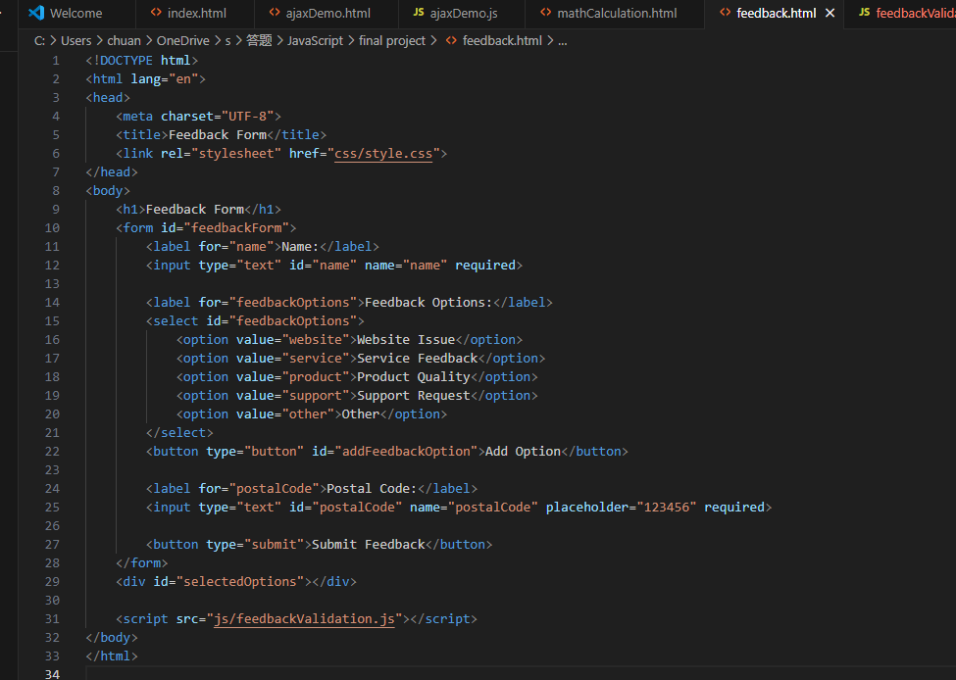

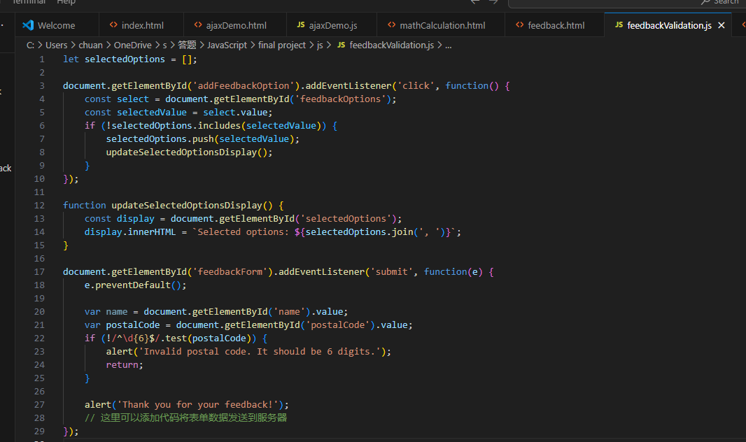

Use the Google Maps API to display the user's current geographic location.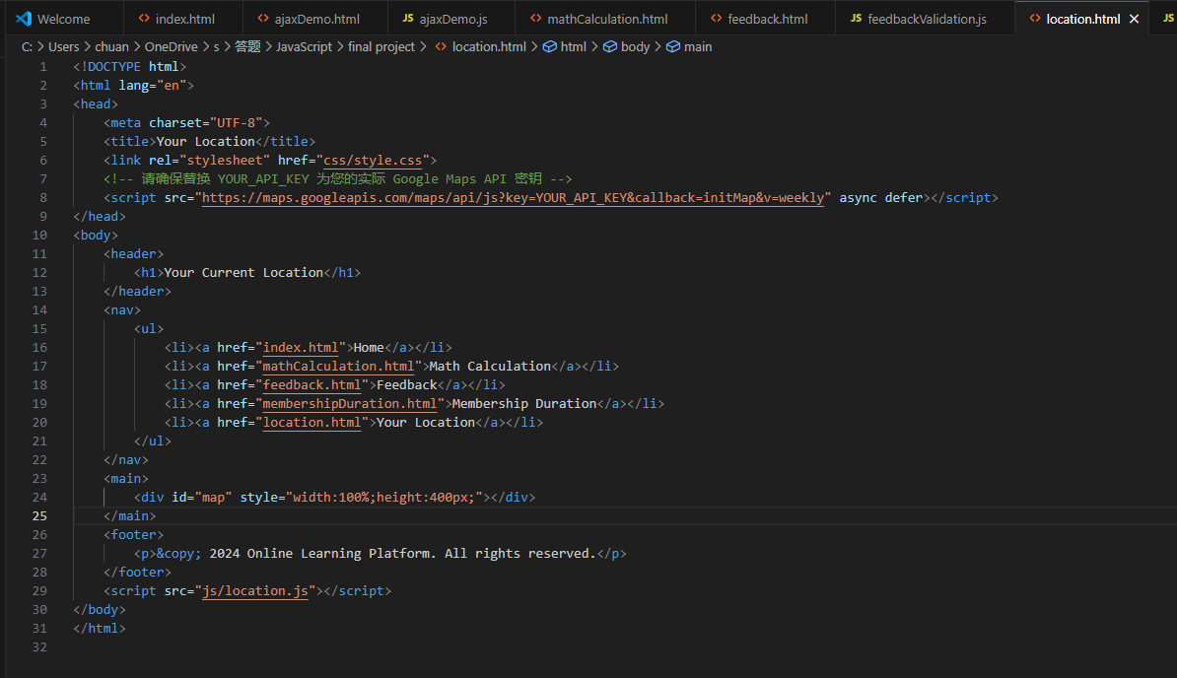

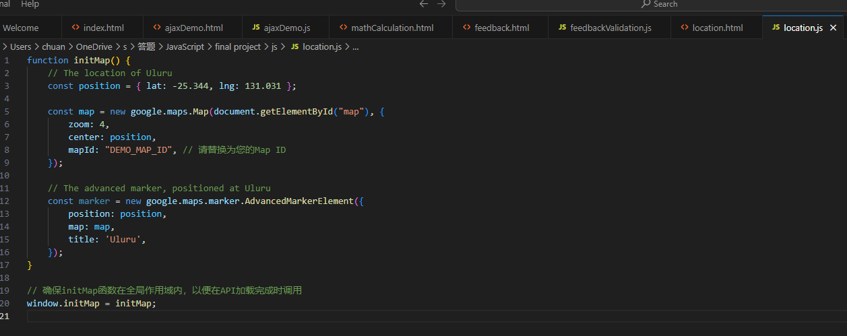

Step6：The page now has basic functionality, but there are a few minor issues, such as multiple pages missing navigation links to jump back to the home page, so it's time to refine those areas.